**Closing Prayer (Option B)**

**L:** Our Father. . .

Let us pray for our particular intentions. That those whom we visit find Your gift of confidence, courage, and peace by our concern for their needs.

**All: Lord, Hear Us.**

L: That our Holy Father, the Pope be enlightened in his leadership, that all Members of the Society, their families, any who may now be in need, and all those who help us in our work be attracted by your love and live fulfilling lives.

**All: Lord, Hear Us.**

L: That the Society and this Conference be blessed with continual growth and renewal in its mission to help overcome suffering.

**All: Lord, Hear Us.**

L: That we accept with new enthusiasm our calling to make visible our unity in Christ by working together with all Christians in service to the needy.

**All: Lord, Hear Us.**

L: That the Cause for the Canonization of Frederic Ozanam, who excelled in the virtue of Christian love, be advanced.

**All: Lord, hear us.**

L: That our departed friends and relatives, our Vincentian Brothers and Sisters, and those whom we have served, be welcomed into Your Kingdom and joined in love.

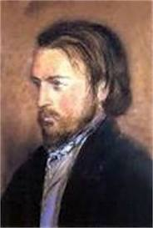

***Blessed Frederic Ozanam***

**Society of St. Vincent de Paul**

**Agenda & Prayers** *for* **Conference Meetings**



**Agenda Conference Meetings**

* A punctual call to order.
* Roll call.
* Opening Prayer (*which should always include a prayer to the Holy Spirit, the Lord's Prayer, the Hail Mary, and a prayer for those whose suffering they wish to share.)*
* Spiritual reading (*or meditation and address on which members are always invited to comment as a means of sharing their faith.)*
* Approval of Minutes of previous meeting.
* Home visitation reports.
* President's report.
* Secretary's report (include correspondence received, information about the Society or training points.
* Treasurer's report.
* Committee reports (*including Formation Committee report.)*
* Membership reports.
* Resolutions.
* Special Works reports.
* Old Business.
* New Business.
* Time & place of next meeting *(the calendar should include Festival meetings and Conference Liturgies.)*
* Festival meetings and Conference Liturgies.)
* Secret collection.
* Closing prayer.
* Adjournment.

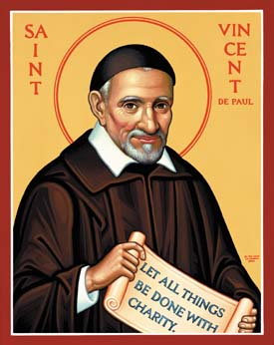

***St. Vincent de Paul***

**Opening Prayer**

L: In the Name of the Father. . . **All: Amen.**

L: Come Holy Spirit, live within our lives.

**All: And strengthen us by Your love.**

L: Send forth Your Spirit and new life will be created.

**All: And the whole face of the earth will be renewed.**

L: Our Father. . .

**All: Give us this day our daily bread. . .**

L: Let us reflect on the words of Our Lord, Jesus Christ, recalling His unity and presence among us: "Where two or three are gathered together in My name there am I in the midst of them." *(Short silence)*

**All: Lord Jesus, deepen our Vincentian spirit of friendship during this meeting, make us responsive to the Christian calling to seek and find the forgotten, the suffering or the deprived so that we may bring them Your love. Help us to be generous with our time, our possessions and ourselves in this mission of charity. Perfect in us Your love and teach us to share more fully in the Eucharistic Sacrifice offered for all.**

L: Most Sacred Heart of Jesus,

**All: Have mercy on us**

L: Immaculate Heart of Mary **All: Pray for us**

L: St. Vincent de Paul **All: Pray for us**

L: St. Louise de Marillac **All: Pray for us**

L: Blessed Frederic Ozanam **All: Pray for us**

L: Blessed Rosalie Rendu **All: Pray for us.**

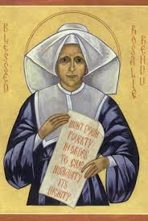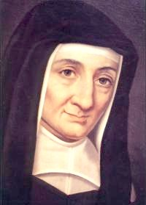

***St. Louise***

***de Marillac***

***Co-founder of the Daughters of Charity***

**Closing Prayer (Option A)**

**All: Father, grant that we who are nourished by the Body and Blood of Christ in the Holy Eucharist may realize the depths of our needs, respond more spontaneously to the suffering of others, and come to love You more deeply by service to our neighbor.**

**Grant us also the wisdom and strength to persevere when disappointed or distressed. May we never claim that the fruitfulness of our apostolate springs from ourselves alone. United in prayer and action, may we become a visible sign of Christ and may we give witness to His boundless love which reaches out to all and draws them to love one another in Him.**

**We thank You, Lord, for the many blessings which we receive from those whom we visit. Help us to love and respect them, to understand their deeper needs and to share their burdens and joys as true friends in Christ.**

L: That the Cause for the Canonization of Frederic Ozanam, who excelled in the virtue of Christian love, be advanced.

**All: Lord, hear us.**

L: That our departed friends and relatives, our Vincentian Brothers and Sisters, and those whom we have served, be welcomed into Your Kingdom and joined in love.

**All: Lord, hear us.**

L: In the name of the Father. . .

**All: Amen**

***Blessed Rosalie Rendu, DC***

***Mentor of Frederic Ozanam & the first Conference of Charity.***